**KPI’S**

**Total Loan Applications**

1. select count(id) as total_loan_applications from financial_loan_data

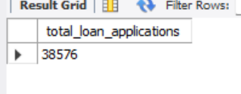

**MTD Loan Applications**

2. select count(id) as total_loan_applications from financial_loan_data where Month(issue_date)=12

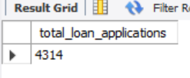

**PMTD Loan Applications**

3. select count(id) as total_loan_applications from financial_loan_data where Month(issue_date)=11

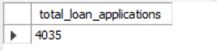

**Total Funded Amount**

4. select sum(loan_amount) as Total_funded_amount from financial_loan_data

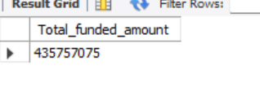

**MTD Funded Amount**

5. select sum(loan_amount) as MTD_Total_funded_amount from financial_loan_data where month(issue_date)=12

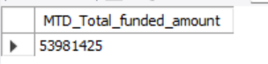

**PMTD Funded Amount**  
6. select sum(loan_amount) as PMTD_Total_funded_amount from financial_loan_data where month(issue_date)=11

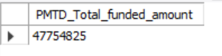

**Total Amount Received**

7.select sum(total_payment) as Total_amount_received from financial_loan_data

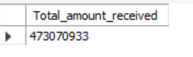

**MTD Total Amount Received**

8. select sum(total_payment) as MTD_Total_amount_received from financial_loan_data where month(issue_date)=12

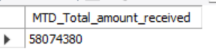

**PMTD Total Amount Received**

9. select sum(total_payment) as MTD_Total_amount_received from financial_loan_data where month(issue_date)=11



**Average Interest Rate**

10. select round(avg(int_rate),2) as Average_interest_rate from financial_loan_data

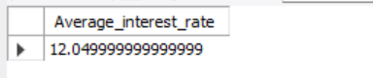

**MTD Average Interest Rate**

11. select round(avg(int_rate),2) as MTD_Average_interest_rate from financial_loan_data where month(issue_date)=12



**PMTD Average Interest Rate**

12. select round(avg(int_rate),2) as PMTD_Average_interest_rate from financial_loan_data where month(issue_date)=11



**Average DTI**

13. select round(avg(dti),4)*100 as Average_dti from financial_loan_data

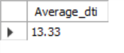

**MTD Average DTI**

14. select round(avg(dti),4)*100 as MTD_Average_dti from financial_loan_data where month(issue_date)=12

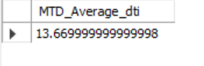

**PMTD Average DTI**

15. select round(avg(dti),4)*100 as PMTD_Average_dti from financial_loan_data where month(issue_date)=11



**Good Loan Percentage**

16. select(count(case when loan_status="Fully paid" or loan_status="Current" then id end)*100)/count(id) as good_loan_percentage from financial_loan_data

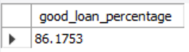

**Good Loan Applications**

17. select count(id) as Total_Goodloan_applications from financial_loan_data where loan_status="Fully Paid" or loan_status="Current"

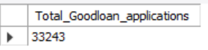

**Good Loan Funded Amount**

18. select sum(loan_amount) as Good_loan_funded_amount from financial_loan_data where loan_status="Fully Paid" or loan_status="Current"



**Good Loan Received Amount**

19. select sum(total_payment) as Good_loan_received_amount from financial_loan_data where loan_status="Fully Paid" or loan_status="Current"

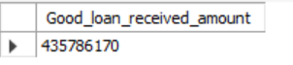

**Bad Loan Percentage**

20. select(count(case when loan_status="Charged Off" then id end)*100)/count(id) as bad_loan_percentage from financial_loan_data



**Bad Loan Funded Amount**

21. select sum(loan_amount) as Bad_loan_funded_amount from financial_loan_data where loan_status="Charged Off"

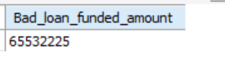

**Bad Loan Received Amount**

22. select sum(total_payment) as Bad_loan_received_amount from financial_loan_data where loan_status="Charged Off"



**Bad Loan Applications**

23. select count(id) as Total_Badloan_applications from financial_loan_data where loan_status="Charged Off"

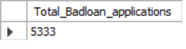

**Loan Status Grid View**

24. select loan_status, count(id) as LoanCount, sum(total_payment) as Total_amount_received,sum(loan_amount)as Total_funded_amount,avg(int_rate*100) as Interest_rate, avg(DTI*100)as DTI from financial_loan_data group by loan_status

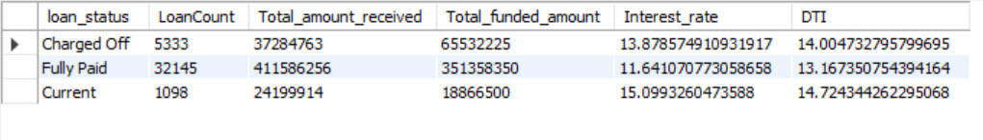

**Loan Status MTD Grid View**

25. select loan_status, sum(loan_amount) as MTD_Total_Funded__Amount, sum(total_payment) as MTD_total_amount_received from financial_loan_data where month(issue_date)=12 group by loan_status

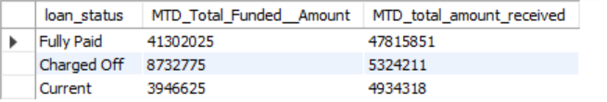

26. select

month(issue_date) as month_number,

date_format(issue_date,'%M') as month_name,

count(id) as total_loan_applications,

sum(loan_amount) as total_funded_amount,

sum(total_payment) as total_received_Amount

from financial_loan_data

group by month(issue_date),date_format(issue_date,'%M')

order by month(issue_date)

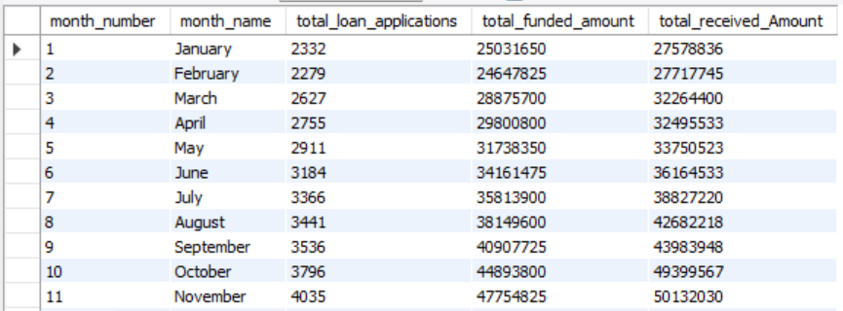

27. select

address_state,

count(id) as total_loan_applications,

sum(loan_amount) as total_funded_amount,

sum(total_payment) as total_received_Amount

from financial_loan_data

group by address_state

order by address_state

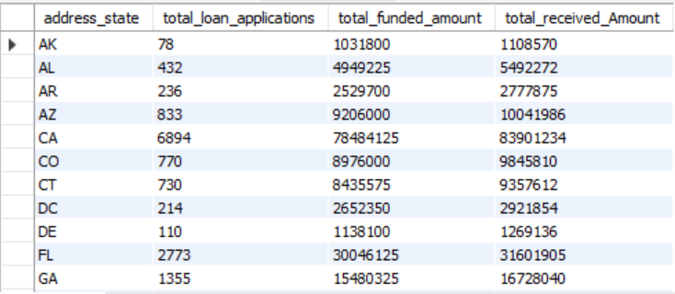

28. select

term,

count(id) as total_loan_applications,

sum(loan_amount) as total_funded_amount,

sum(total_payment) as total_received_Amount

from financial_loan_data

group by term

order by term

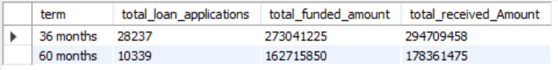

29. select

emp_length,

count(id) as total_loan_applications,

sum(loan_amount) as total_funded_amount,

sum(total_payment) as total_received_Amount

from financial_loan_data

group by emp_length

order by emp_length

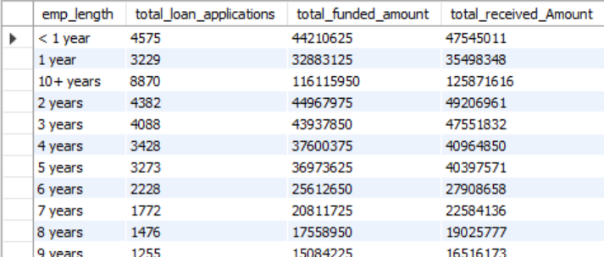

30. select

purpose,

count(id) as total_loan_applications,

sum(loan_amount) as total_funded_amount,

sum(total_payment) as total_received_Amount

from financial_loan_data

group by purpose

order by count(id) Desc

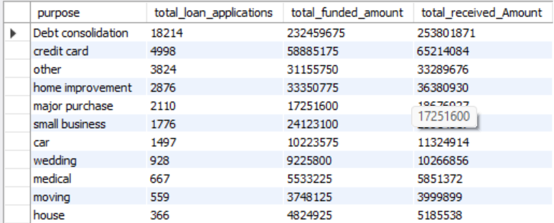

31. select

Home_Ownership,

count(id) as total_loan_applications,

sum(loan_amount) as total_funded_amount,

sum(total_payment) as total_received_Amount

from financial_loan_data

group by Home_Ownership

order by count(id) Desc

